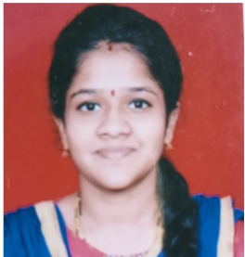

**Contact : Career objective:**

**Email**: [bhagya.dusa11@rediffmail.com](mailto:bhagya.dusa11@rediffmail.com) .To be associated with an organization which provide challenging

**Mobile :**9892880430 work

**Location:** Mumbai.

**Github :<mailto:dusabhagya2@gmail.com>**

**Education :**

**12th Science.**

(Chandrabhan college Powai.)

**Bachelor of sience in Computer Science.**

(Distance Learning)

**Full stack Web Development**

(Skill Academy)

**Skills :**

Html.

Css.

Javascript.